EASTERN AFRICA STATISTICAL TRAINING CENTRE
DSU07210 — Linux Systems Administration
Group Assignment Submission Template
Data Science Year 1 | Academic Year 2025/2026

A. Group & Assignment Information

Group & Assignment Details
Assignment No. | 1 | Session | C
Assignment Title | Linux Systems Administration
Group No. | 10 | Date Submitted | 7th June 2026
Academic Year
2025 / 2026

B. Group Members
List all group members. The Role/Task column should show which task(s) each member led.

# | Full Name | Reg. Number | Session | Role / Task
1 | FREDY RESPICHIUS MATUNGWA | EASTC/BDTS/26/04195 | 10 C | Group organizer& Led Task 1 report wrote
2 | TEKLA JOHN MKUDE | EASTC/BDTS/25/02469 | 10 C | Code verifier and report wrote( self)
3 | MARIA AGUSTINO KIKOTI | EASTC/BDTS/26/04694 | 10 C | Led Task 4 & creativity idea bringer
4 | GLORY PETER SALUM | EASTC/BDTS/26/04583 | 10 C | Led Task 5 & creativity idea
5 | KELVIN EMANUEL SILVESTA | EASTC/BDTS/25/01903 | 10 C | Led Task 2 &3 Screenshot
6

C. Assignment Instructions Summary
Before starting, re-read the full assignment from your lecturer. Then tick the boxes below as you complete each task.

- Every command must be run on a real Linux terminal.
- Screenshots or terminal recordings are required as evidence.
- Complete the Creativity Challenge with a scenario your group designs.
- Each member completes the Self-Exploration section individually.
- Submit this template as your group report (printed or PDF).

D. Task Completion Checklist
For each task: briefly describe what your group did, mark whether it is complete, and note the evidence (e.g. screenshot filename or page number in your terminal log).

# | Task Description (summarise what you did) | Done? (Yes/No) | Evidence
1 | We start task by creating 3 directory Files namely { company/hr/record ,company/it/scripts and company/finance/report using mkdr command | Yes done | 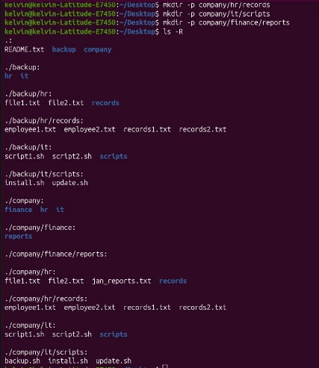
2 | We populate our files in a directory into 2 placeholder using touch command | Yes done | 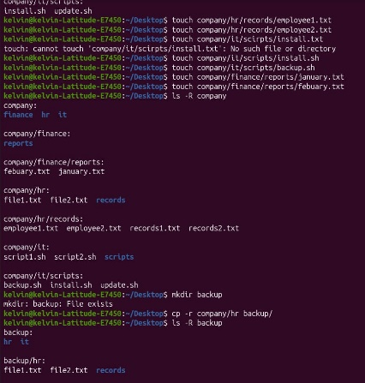
3 | After populate we copy one entire department folder to a new location called backup/. | Yes done | 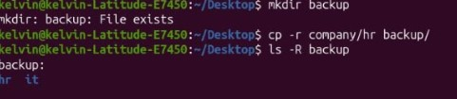
4 | By using mv command we resume a File and move it across two directory lever | Yes done | 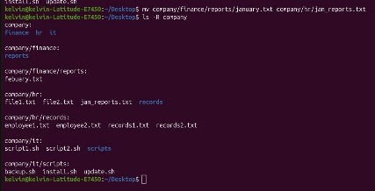
5 | Finally we safely delete an empty directory files using rmdir and non-empty one using rm- | Yes done

E. Command Evidence Log
Record the key commands your group ran. Attach screenshots after this page or include terminal output in an appendix.

# | Task Ref. | Command(s) Run / Description | Screenshot?
1 | Task 1 | mkdr –p company/hr/record company/it/script and company/finance/report  (create a 3-lever directory tree structure) | 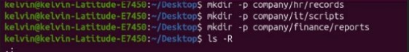
2 | Task 2 | (To populate the directory with placeholder files)  Command:  touch company/hr/record/file.txt  touch company/it/script/file.txt
3 | Task 3 | (We copy the entire foldler to a new backup location)  Command:  cr –r company/ backup/ | 
4 | Task 4 | ( Renames and move a file across two levels)  Command:  mv company/hr/record/file1.txt  mv company/it/script/new_file.
5 | Task 5 | (Delete an empty file in directory file and non-empty file)  Command:
6
7
8

F. Creativity Challenge
Describe the real-world scenario your group chose and explain your creative design decisions.

Creativity Challenge
Scenario we chose:

Our creative approach:

G. Self-Exploration (Individual — one per member)
Each group member must complete their own copy of this section. Photocopy this page or attach separate sheets — one per member.

Student Name: ________________________________ Reg. No.: ___________________________

Self-Exploration Findings
Exploration question answered:

Key commands tested:

What I discovered:

H. Group Member Contributions
Briefly describe what each member contributed. The percentages must add up to 100% per task (or you can distribute overall contribution).

Member Name | Specific Contribution | % Contribution
FREDY RESPICHIUS MATUNGWA | Ran command for task 1 and Formulate final report layout and verified and declear whole report | 20%
KELVN EMANUEL SILVESTA | Excute Task 2 and 3 ( touch and backup creation) and capture all screenshot | 20%
MARIA AGUSTINO KIKOTI | Solve Task 4 and provide an idea for the Creativity Challenge design | 20%
GLORY PETER SALIM | Solve Task 5 and also bring an idea for our Creativity Challenge design | 20%
TEKLA JOHN MKUDE | Participate in solving tasks by verified commands also wrote the individual Self_Exploration report | 20%
J. Declaration
We declare that this is our own group work. All commands were run on a real Linux system. All members participated as recorded above. We have not copied work from another group.

Group Leader Signature:

Date: ____________________________

EASTC | DSU07210 Linux Systems Administration | 2025/2026

